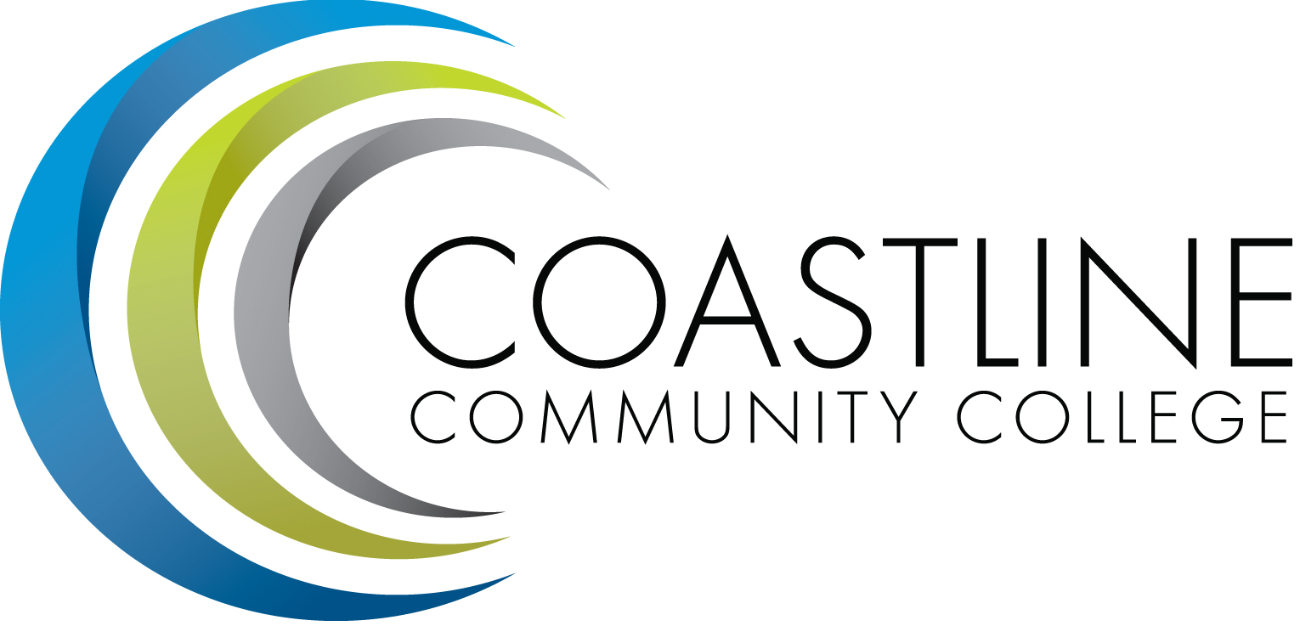

Facilities, Safety and Sustainability Committee Meeting (FSSC) 2017-2018
Thursday, September 14, 2017
3:00 p.m. – 5:00 p.m.
College Center – Fourth Floor Conference Room

Committee Mandate: The Facilities, Safety, and Sustainability Committee is mandated to review and plan for Facilities to house sites, programs, and college operations. Safety is to review and recommend procedures and practices to ensure maximum levels of safety and health for all College operations including ADA compliance. The committee will explore and promote avenues of sustainability that the College can use to become a more environmentally responsible campus.

CALL TO ORDER
  - Welcome
  - Adoption of Agenda
  - Approval of Minutes : May 11, 2017
  - Review the Mandate and Charge of the Facilities, Sustainability and Safety Committee – C. Nguyen

REPORTS
  - Measure M Report – C. Nguyen

DISCUSSION
  - Le-Jao Café Renovation – C. Nguyen
  - Newport Beach Café – C. Nguyen
  - College Center Renovation – C. Nguyen

ACTION
  - Follow-up from March 9, 2017 Meeting
    - Install signage that is clearly visible for Parking Permit Dispenser at GGC –
Dave Cant – An estimate for pricing of the Parking Permit machine is in process at this time. Should be completed and installed by the end of May (if PORs are processed by District in a timely manner) ONGOING
    - Relabel parking spaces designated for staff at GGC-
Dave Cant – Will be completed during the summer break before fall semester begins. ONGOING
  - Follow-up from April 13, 2017 meeting (new items)
    - A task force will be established by the Area Facilitators in order to develop a process and protocol for posting of items on bulletin boards. Follow-up Report will be provided in September. DEFERRED TO SEPTEMBER

STANDING REPORTS
  - Area Update Le-Jao Center – J. DeBattista
  - Area Update Newport Beach Center – K. Bledsoe
  - Area Update Garden Grove Center – C. Berry
  - Area Update College Center/Construction Projects Update – D. Cant
  - Campus Safety Report – M. Colver
    - Emergency phones
    - Free Speech
    - Evacuation at NBC
    - Emergency Generator
    - American Red Cross Disaster Preparedness Academy

ANNOUNCEMENTS
  - Next Meeting: Thursday, October 12, 2017, 3:00-5:00 p.m. CC 4th Floor Conference Room

ADJOURNMENT

